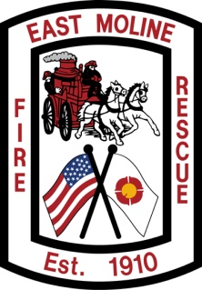
AGENDA
EAST MOLINE FOREIGN FIRE BOARD
January 27, 2026, at 9:00 A.M.
1523 Morton Drive, East Moline, IL 61244
Station #22 Training Room

Call to Order

Reports
- Approval of Minutes from meeting on November 25, 2025.
- Approval of Treasurer’s Report for January 2026.

Old Business
- Bumper plate racks for all stations status
- Coffee maker for st23 status
- Coffee pots for st23 status
- Rowing machine for st22 status
- Tool box for st23 status
- Revote on tabled set of irons by Gripp
- RIT straps status

New Business

- Current purchase requests forms
- 2026 board seat elections

Other Business

Adjourn

NEXT MEETING: Tuesday, February 24, 2026, at 0900hrs

